ReactJS Hands-On Lab
Blog App – Fetching and Displaying Posts

Objective
In this lab I created a React app named blogapp that fetches a list of blog posts from a public API (jsonplaceholder.typicode.com) and displays each post's title and body on the page using a class based component.

Step 1: Creating the React app
I opened the command prompt inside my lab folder and ran the create-react-app command to scaffold a new project named blogapp:
npx create-react-app blogapp
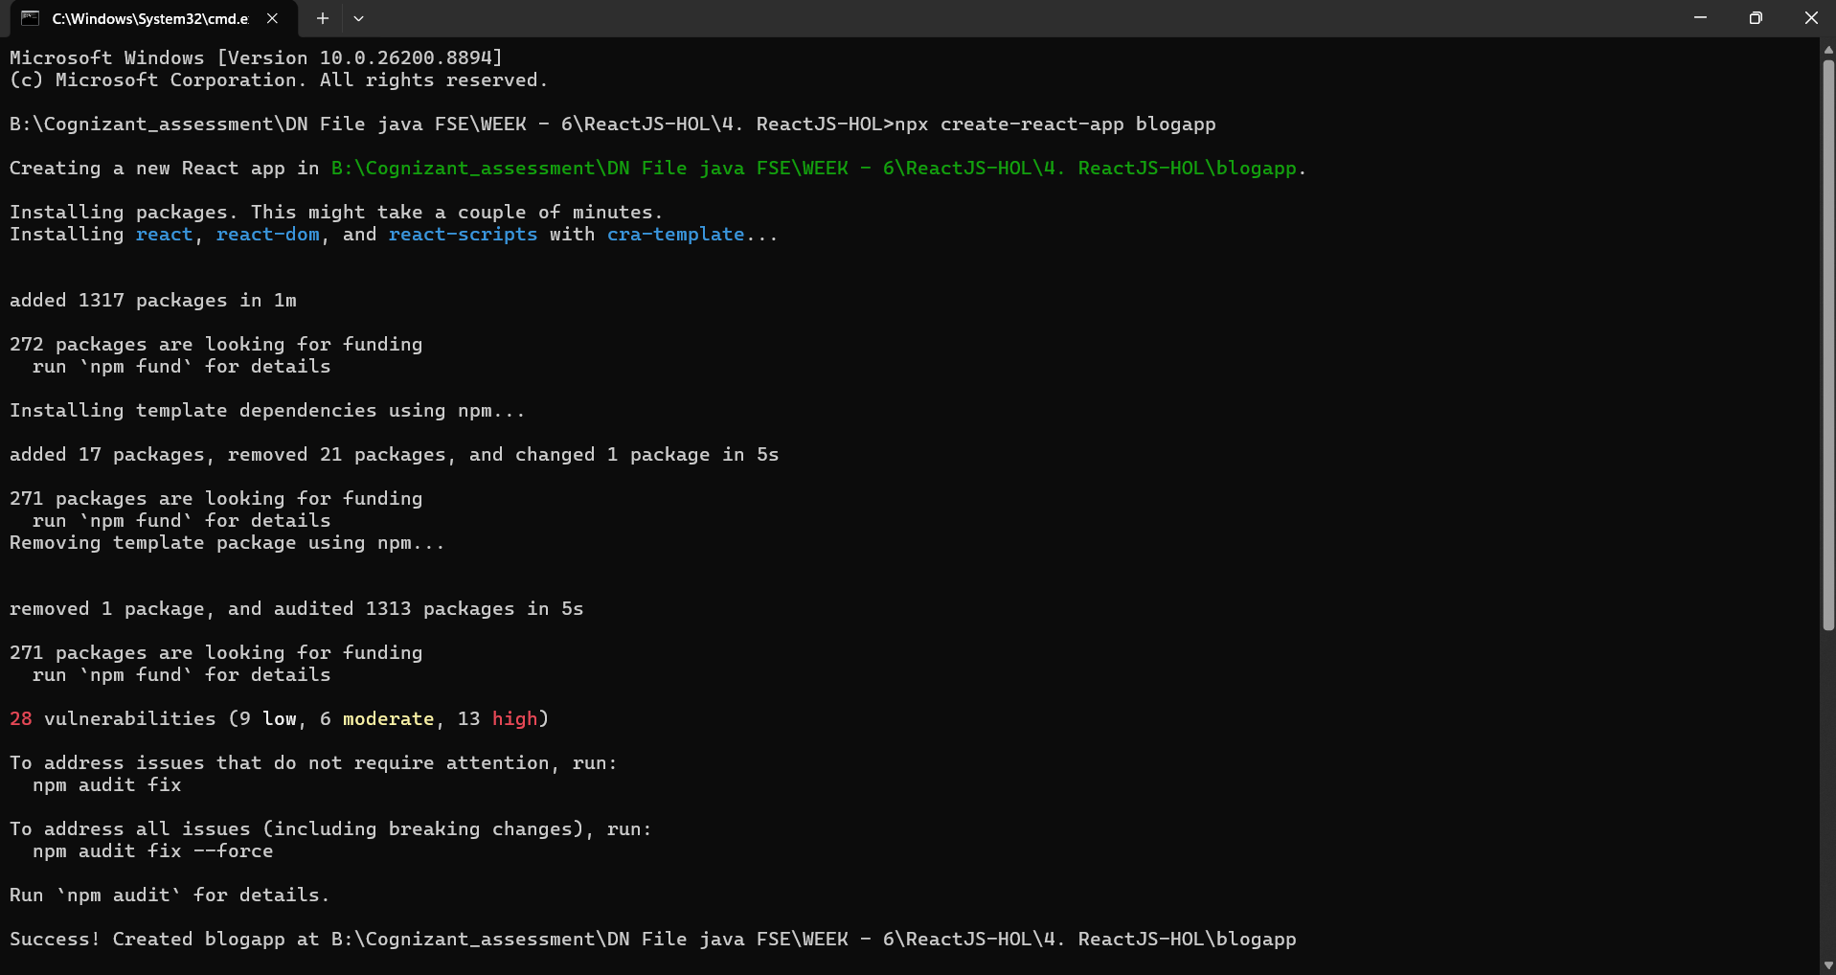
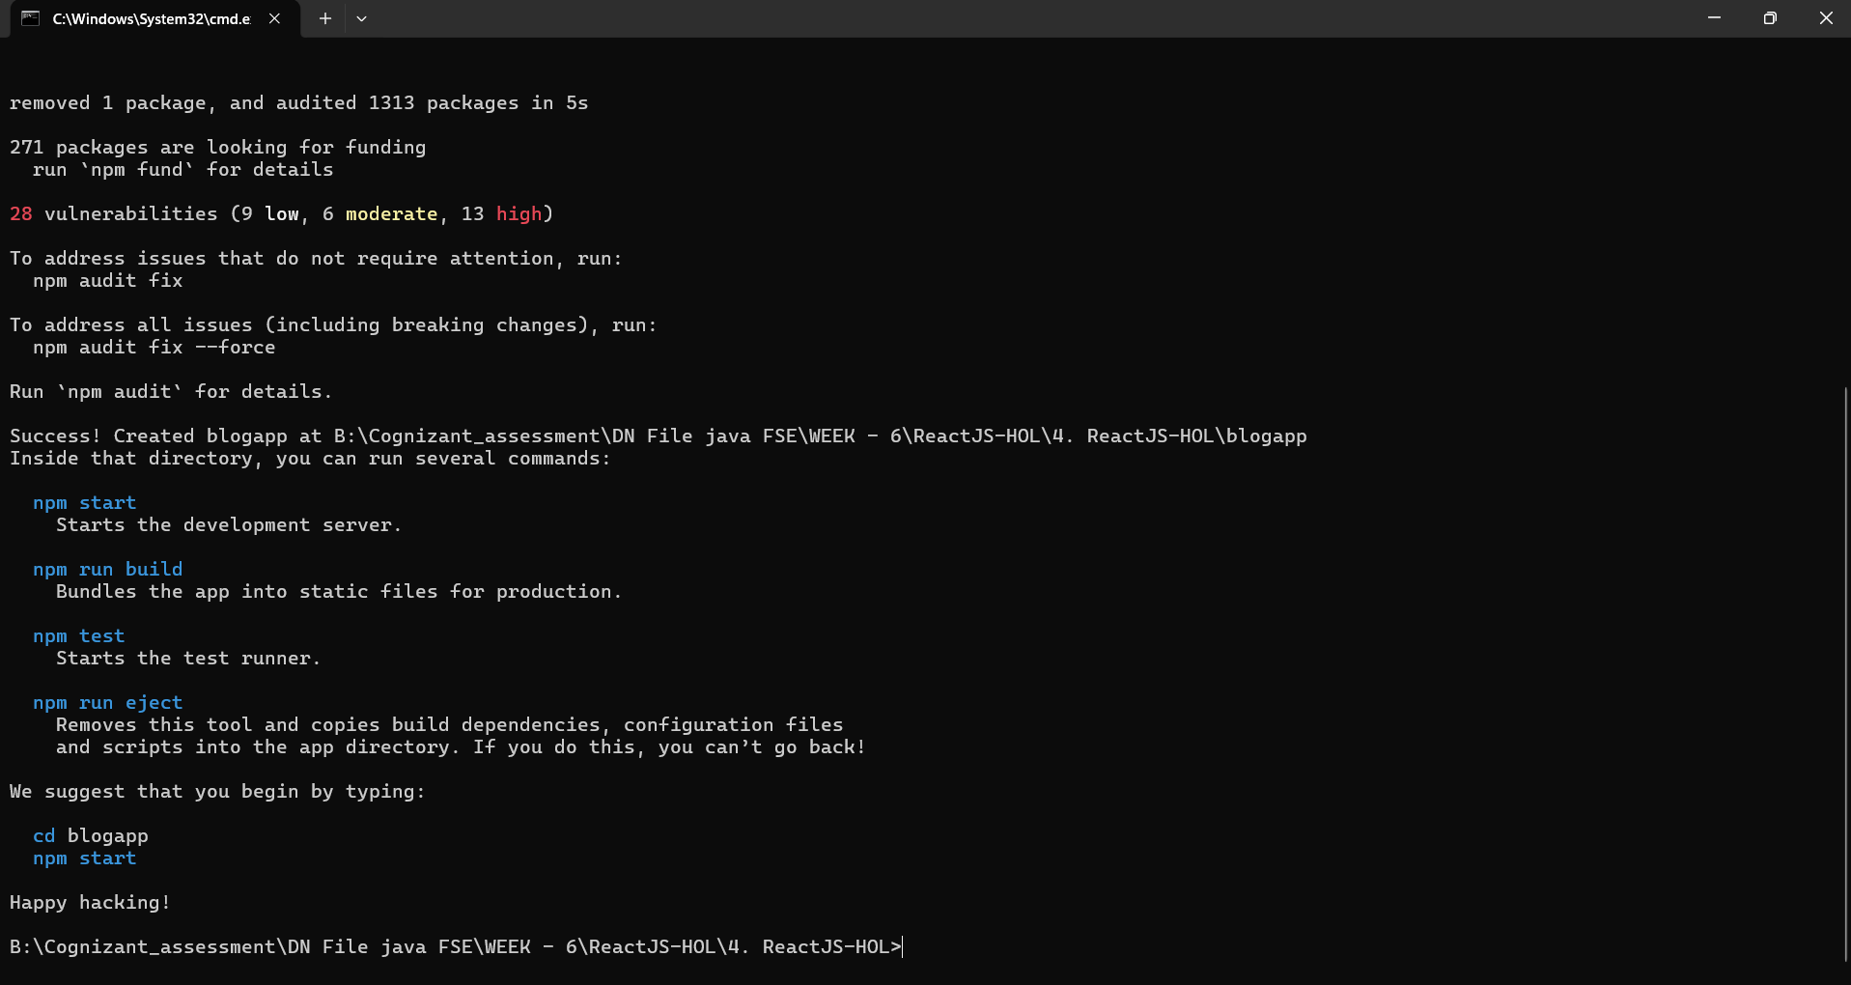
The packages installed successfully and the terminal confirmed the project was created at the correct path, along with the usual set of npm commands I can use inside it.

Step 2: Creating the Post model
Inside the src folder, I created a file named Post.js that defines a simple Post class with id, title and body properties:
class Post {
constructor(id, title, body){
this.id=id;
this.title=title;
this.body=body;
}
}
export default Post;

Step 3: Creating the Posts component
Next, I created Posts.js with a class based component called Posts. In the constructor I initialized the component's state with an empty posts array. I then added a loadPosts() method that uses the Fetch API to get the data from https://jsonplaceholder.typicode.com/posts and store it in the state, and called this method from the componentDidMount() lifecycle hook so the data loads as soon as the component mounts. The render() method loops through the posts in state and displays each post's title as a heading and its body as a paragraph. I also added a componentDidCatch() method to show an alert if any error occurs while rendering:
import React from 'react';
class Posts extends React.Component {
constructor(props){
super(props);
this.state = {
posts: []
};
}
loadPosts() {
fetch('https://jsonplaceholder.typicode.com/posts')
.then(response => response.json())
.then(data => {
this.setState({ posts: data });
});
}
componentDidMount() {
this.loadPosts();
}
render() {
return (
<div>
{this.state.posts.map(post => (
<div key={post.id}>
<h2>{post.title}</h2>
<p>{post.body}</p>
</div>
))}
</div>
);
}
componentDidCatch(error, info) {
alert(error + " " + info);
}
}
export default Posts;

Step 4: Adding Posts to App.js
I then updated App.js to import the Posts component and render it:
import Posts from './Posts';
function App() {
return (
<div>
<Posts />
</div>
);
}
export default App;
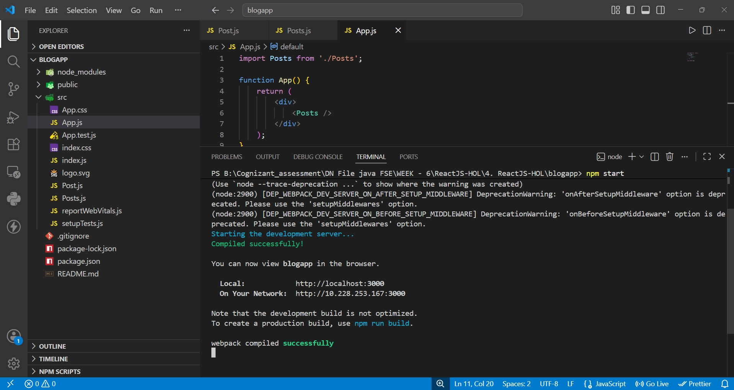
The screenshot above shows the final App.js file open in VS Code, along with the terminal output after running npm start — the app compiled successfully with no errors.

Step 5: Running the app
From inside the blogapp folder, I ran npm start, which launched the development server and opened the app at localhost:3000 in the browser:
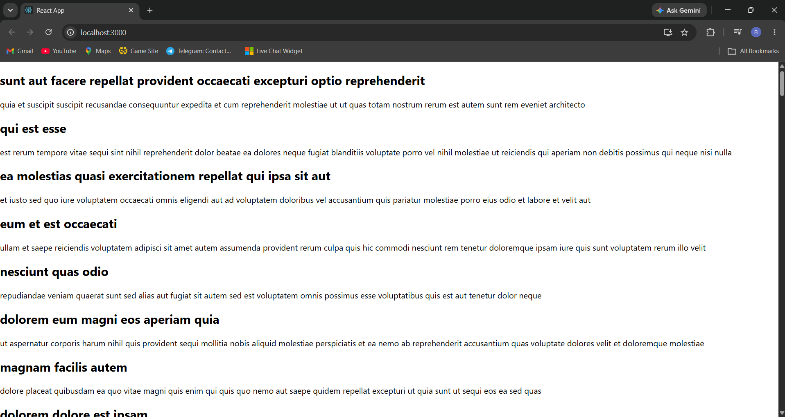
The page displays every post fetched from the API, with each post's title shown in bold as a heading and its body text shown below it as a paragraph, confirming that the fetch call, state update and rendering are all working correctly.

Conclusion
This lab helped me understand how to create a class based component in React, initialize and update its state, fetch data from an external API using the Fetch API, and use lifecycle methods like componentDidMount() and componentDidCatch() to load data and handle errors. The final output correctly lists all the blog posts retrieved from the API.

